LAB

REPORT

# IRE 212 : IoT Architecture and Technologies Sessional

|  |  |
| --- | --- |
| PREPARED BY  Mehrin Farzana  ID: 2101013  Session: 2021-2022  Date: 5/11/2024 | SUPERVISED BY  Suman Saha  Assistant Professor & Chairman  Department of IRE, BDU |

|  |  |
| --- | --- |
| logo1 | BANGABANDHU SHEIKH MUJIBUR RAHMAN DIGITAL UNIVERSITY  (BDU) |
|  |  |

**List of Experiments**

* 1. Arduino Air Quality Monitoring System

**Experiment No.:** **01**

**Experiment Statement: Arduino Air Quality Monitoring System**

Components and supplies:

* •Arduino board
* •MQ135 gas sensor for detecting various gases.
* •DHT11 temperature and humidity sensor
* •OLED display for visual output
* •Breadboard and jumper wires•

**Circuit:**

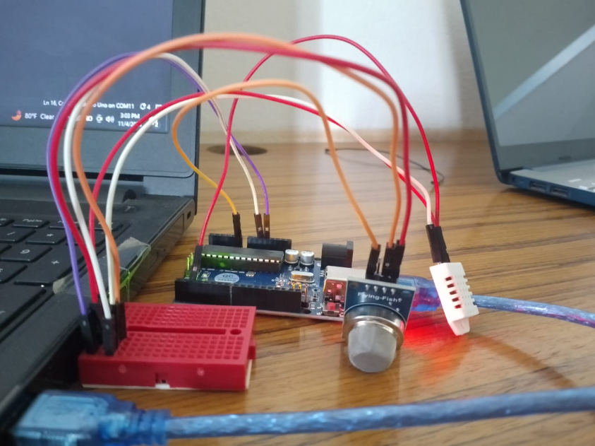

Figure 1: Circuit of Air Quality Monitoring System

**Code:**

#include <SPI.h>

#include <DHT.h>

#define sensor A0

#define DHTPIN 2      // Pin where the DHT sensor is connected

#define DHTTYPE DHT11 // Define the type of DHT sensor used (DHT11 or DHT22)

int gasLevel = 0;

String quality = "";

DHT dht(DHTPIN, DHTTYPE); // Create an instance of the DHT class

void setup() {

    Serial.begin(9600);

    pinMode(sensor, INPUT);

    dht.begin(); // Initialize the DHT sensor

}

void sendSensor() {

    // Function to read temperature and humidity from the DHT sensor

    float h = dht.readHumidity();    // Read humidity

    float t = dht.readTemperature();  // Read temperature

    if (isnan(h) || isnan(t)) {

        Serial.println("Failed to read from DHT sensor!");

        return; // Return if reading fails

    }

    // Output to Serial Monitor

    Serial.print("Temperature: ");

    Serial.print(t);

    Serial.println(" °C");

    Serial.print("Humidity: ");

    Serial.print(h);

    Serial.println(" %");

}

void air_sensor() {

    gasLevel = analogRead(sensor);

    if (gasLevel < 151) {

        quality = "GOOD!";

    } else if (gasLevel >= 151 && gasLevel < 200) {

        quality = "Poor!";

    } else if (gasLevel >= 200 && gasLevel < 300) {

        quality = "Very bad!";

    } else if (gasLevel >= 300 && gasLevel < 500) {

        quality = "Toxic!";

    } else {

        quality = "Toxic";

    }

    // Output to Serial Monitor

    Serial.print("Gas Level: ");

    Serial.print(gasLevel);

    Serial.print(" - Quality: ");

    Serial.println(quality);

}

void loop() {

    // Read and display sensor data

    air_sensor();

    sendSensor();

    // Add a delay to avoid flooding the Serial Monitor

    delay(2000); // Adjust delay as needed

}

**Explanation of Code:**

This Arduino code uses an analog gas sensor and a DHT11 temperature and humidity sensor to monitor air quality, temperature, and humidity levels. Here's a breakdown of the main parts of the code and the output it produces:

Library and Sensor Setup:

* •#include <SPI.h> and #include <DHT.h>: Imports the necessary libraries for handling SPI communication and the DHT sensor.
* •#define DHTPIN 2 and #define DHTTYPE DHT11: Specifies that the DHT sensor is connected to pin 2 and uses the DHT11 type.
* •DHT dht(DHTPIN, DHTTYPE): Creates an instance of the DHT class to interface with the sensor.

sendSensor() Function:

* •Reads humidity and temperature values from the DHT sensor.
* •If readings fail (isnan(h) or isnan(t)), it prints an error message.
* •If successful, it prints temperature and humidity values to the Serial Monitor.

air_sensor() Function:

Reads the analog value of the gas sensor and assigns a corresponding air quality label:

* •<151: "GOOD!"
* •151 - 199: "Poor!"
* •200 - 299: "Very bad!"
* •300 - 499: "Toxic!"
* •>=500: "Toxic"

Outputs the gas level and quality to the Serial Monitor.

**Output:**

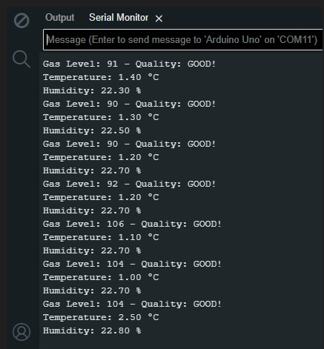

Figure 2: Output